**AWS**

* Let’s generate subnet cidr range  
  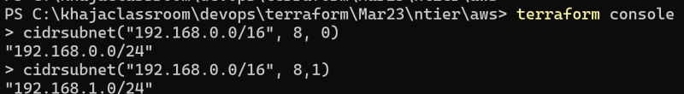
* <https://github.com/asquarezone/TerraformZone/commit/ac2ffd5be12da24071bbab271bb341daade0ec7d> for the changes done to use cidrsubnet function and object input type and
* Terraform plan is generated whenever we apply

**Azure**

* Let’s add subnets. refer below for manual steps  
  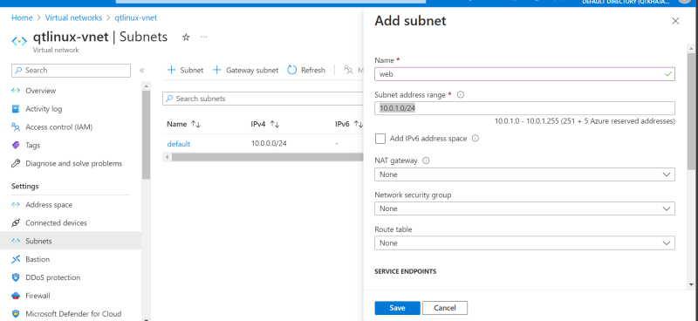
* <https://github.com/asquarezone/TerraformZone/commit/d4f087ab33a45b1cf9520dc999804fe74cd74f91> for the changes done  
  